
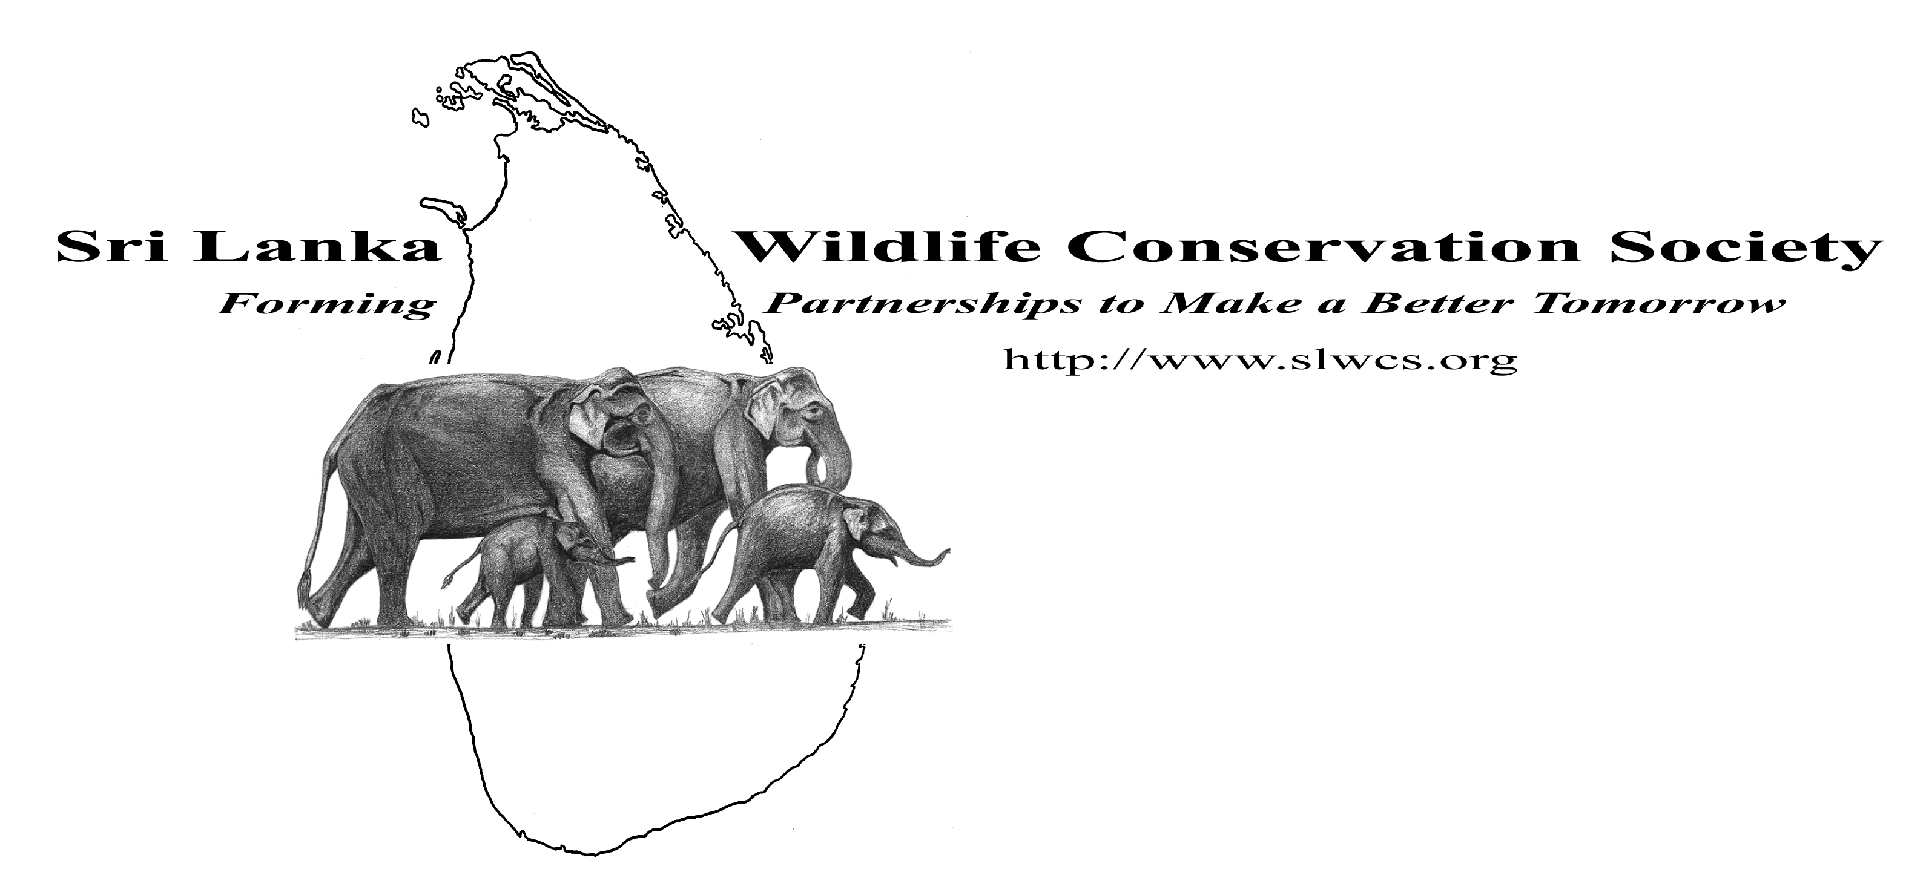
Patron:
His Excellency Sri Lanka Ambassador to the United States of America

PILOT ENVIRONMENTAL EDUCATION PROGRAM CONDUCTED AT HULLANUGE, LAHUGALA, AND PANAMA GNDs IN THE LAHUGALA DSD, AMPARA DISTRICT, EASTERN PROVINCE
Summary
Research showed that the local communities in Lahugala and Panama have no awareness about environmental issues and concerns or at the most have only a very moderate knowledge of environment and ecology. The weakest aspects are:
- The relevance of forests for rainfall, soil erosion, nutrient cycling, biodiversity, global warming and climate change.
- Desertification and its occurrence in other parts of the world.
- The importance of biodiversity to agriculture, agriculture biodiversity, and it impacts on their own livelihoods.
The SLWCS pilot environmental education program was designed specifically to address these shortcomings.
The following publications and printed materials were distributed to the schools:
1. Sri Lanka Theth Bim Sampath Sisu Athpotha by Professor Sarath Kotagama.  2. Sri Lanka Ekadeshika Miridiya Masun - By National Aquatic Research Authority (NARA)  3. Kadolana (Mangroves) - By NARA  4. Mammals of Sri Lanka by Professor Sarath Kotagama  5. A guide to the Slender Lorises of Sri Lanka- By Saman Gamage et al  6. Common birds poster by Professor Sarath Kotagama  7. Bird alphabet poster by Professor Sarath Kotagama  8. NARA poster on the sea turtles of Sri Lanka | 9. Endemic birds 1 & 2 posters prepared by Professor Sarath Kotagama  10. NARA marine mammals poster  11. NARA endemic fresh water fishes poster  12. Parisara ath potha by Professor Sarath Kotagama  13. Pasa Sinhala/Tamil by Professor Sarath Kotagama  14. Diya Sinhala/Tamil by Professor Sarath Kotagama  15. Pana Sinhala/Tamil by Professor Sarath Kotagama  16. The wading birds by Professor Sarath Kotagama  17. Mammals of Sri Lanka posters 1 & 2 by SLWCS and University of Peradeniya
Following items were provided to the students:
1. Common Birds poster  2. Sea turtles of Sri Lanka poster  3. Endemic Birds 1 & 2 posters | 4. CR note book  5. Pen
In addition refreshments were provided to the students and the teachers who participated in the program.
In total 329 school students and seven teachers from four public schools and an additional twenty young school leavers were educated through the program.
School | Age range | Boys | Girls
Am/Lahugala Mahavidyalaya | 14-16 | 25 | 40
Am/Hulannuge Vidyalaya | 12-16 | 18 | 24
Am/Paranigovipola Vidyalaya | 11-14 | 17 | 14
Am/Panama Mahavidyalaya | 15- 16 | 86 | 105
Educational level of target groups:
All the selected students were yet to sit for their GCE Ordinary Level examinations. Most of them were also members in their respective school environment societies.
Age groups:
All the students other than for the 20 young school leavers were between the ages of 11 and 16 years.
PROGRAM ACTIVIES AND IMPACT
The schools were selected based on the rich biodiversity and the diverse environmental problems that exist in their respective areas. The selection of the students for the program was done by the school Principal and the Science Teacher giving priority to the students who were keen to participate in the School Environmental Society activities. The presentations that were delivered to the students contained a broad spectrum of topics such as biodiversity, birds, butterflies, arthropods, turtles, environmental issues and conservation. This was to give them a general overview of conservation, ecology and the interrelationships within an ecosystem.

During the program questions were asked to test their knowledge on biodiversity and the environment. The students who answered questions correctly were rewarded by presenting them books on the environment. An outdoor field observation session was conducted at Kumana Villu to give a basic introduction to field observations, record keeping and how to use field equipment such as binoculars, GPS, spotting scopes, etc.

The lessons on arthropod diversity and the key to identify arthropods directly relates to the science curriculum of the schools.

The importance of forests for rainfall, to arrest soil erosion, maintain watersheds, assists in nutrient cycling, maintain biodiversity, and help combat global warming and climate change was discussed. The process of desertification and how widespread it is in other parts of the world and information about how it occurs and what can be done to avoid desertification via reforestation, conservation and management of water catchment areas was also provided.

The importance of biodiversity to agriculture, agriculture biodiversity and its importance to their livelihoods were discussed. Students were given a comprehensive understanding on biodiversity and how it is important for sustainable agriculture.
The lecturers and instructors who conducted the Environmental Education Program
Mr. Wasantha Liyanage (BSc, M.Phil) is currently attached to the Ministry of Environment and Natural Resources and is the National Coordinator of the Green Village Program. He has more than ten years experience conducting environmental education programs as a former school teacher and a researcher and is about to receive his PhD from the University of Geo-science of China. He conducted the presentations on Arthropod Diversity, Friends of Farmers and Diversity Key. He also demonstrated to the students how to classify wildlife using morphological variations.
Mr. Chaminda Pushpakumara (BSc) works as a Demonstrator at the University of Ruhuna. He has more than three years field experience working as a Research Assistant and a Dhamma School Teacher. He conducted the presentations on birds, biodiversity and conservation.
Mr. Samantha Mirandu. BSc (Special Honors) is currently working as the Biodiversity Projects Manager of the Sri Lanka Wildlife Conservation Society. He has more than three years field research experience as a field assistant, research assistant and a researcher. He conducted the presentations on butterfly identification, ecology and conservation, turtle identification, ecology and conservation and on biodiversity and agriculture biodiversity. Samantha conducted a field class at the Kumana Villu to demonstrate to students how to use scientific equipment to conduct field observations.
Topics covered by the lectures
Topics | Subtopics
Arthropods | Identification of Arthropods, Why are they important? Classification and conservation of arthropods.
Biological Friends of Farmers
Diversity Key to classify the fauna and flora using morphological and external features.
Biodiversity conservation | What is diversity? What is biodiversity? Why is biodiversity important? How is biodiversity useful? The importance of biodiversity and biodiversity conservation for sustainable development.
Birds | Bird identification. Why birds are important? And the need for bird conservation.
Butterflies | Why butterflies are important? Identification, ecology of butterflies and conservation of butterflies.
Sea Turtles | Sea turtle identification, ecology and conservation

Method of Delivery
- Graphic Power Point presentations which included charts, graphs and video clips to deliver the information.
- Discussions with students.
- Field class on how to observe animals in the wild and how to use field equipment.
Expected Outcome
- Increased knowledge on biodiversity and biodiversity conservation.
- Active participation in conservation activities at the grass roots level.
- Promote an environmental ethic amongst contemporaries.
Issues & Challenges
- Obtaining permission from relevant regional education authorities.
- Selecting students who are keen to learn conservation.
- The time allocated by the schools for the environmental education program was inconvenient for the students.
- Security issues to conduct field sessions and other outdoor activities.
- Funds to provide for a large number of students.
- Lack of Tamil material
- Lack of low cost material that is designed for a rural audience
Conclusions and Recommendations
The environmental education program was requested by school authorities and students which demonstrate that knowledge about environmental issues and concerns is desired by the community. It is therefore critical to the national conservation efforts to encourage and foster this desire in rural communities whose disproportionate dependency on natural resources leads to major impacts on the environment.
In order to derive the optimum benefit from this introductory pilot environmental education program there must be follow up efforts in order to reinforce knowledge already imparted and to expand and build upon it so that committed conservationists will emerge from within these communities.
Plans have been made to conduct the program for an additional 200 students from the Pothuvil DS Division which will include Tamil medium students.
Recommendations for Program Continuity:
- Monitor and evaluate the program to assess the impact of the pilot program and educational materials distributed.
- Establish a fully developed environment education program as a follow up to this initial effort.
- Identifying a panel of external resource personnel from academia and the field to be instructors.
- Explore the possibility of harnessing private sector sponsorships for the program.
- Encourage the students to actively participate in conservation projects and programs in their areas.
- Train and educate the students in the field using conservation outreach techniques.

